Homework 3

Modification to the datapaths and state machines
As asked we changed our datapaths and our state diagrams to make the cache become a write-through and write-no-allocate cache. We dropped the write-back behaviour.

- State machines modifications

Cache Controller Read

Here we removed the states « wait bus grant writeback » and « wait bus grant complete », and changed the transitions to be adequate. Indeed, this two states are only useful for writebacks as indicates their names, and now we can only use the write-through arrow going from « wait bus complete » to idle. All the transaction now are directly sent to the memory when we miss.

Cache Controller Write

Here, we only removed the « tagWrDirty » signal, because it does not more exist because we removed the write-back and replaced it with a write-through.

The Bus Controller State machine stays unchanged.

- Datapaths modifications
Bus controller datapath
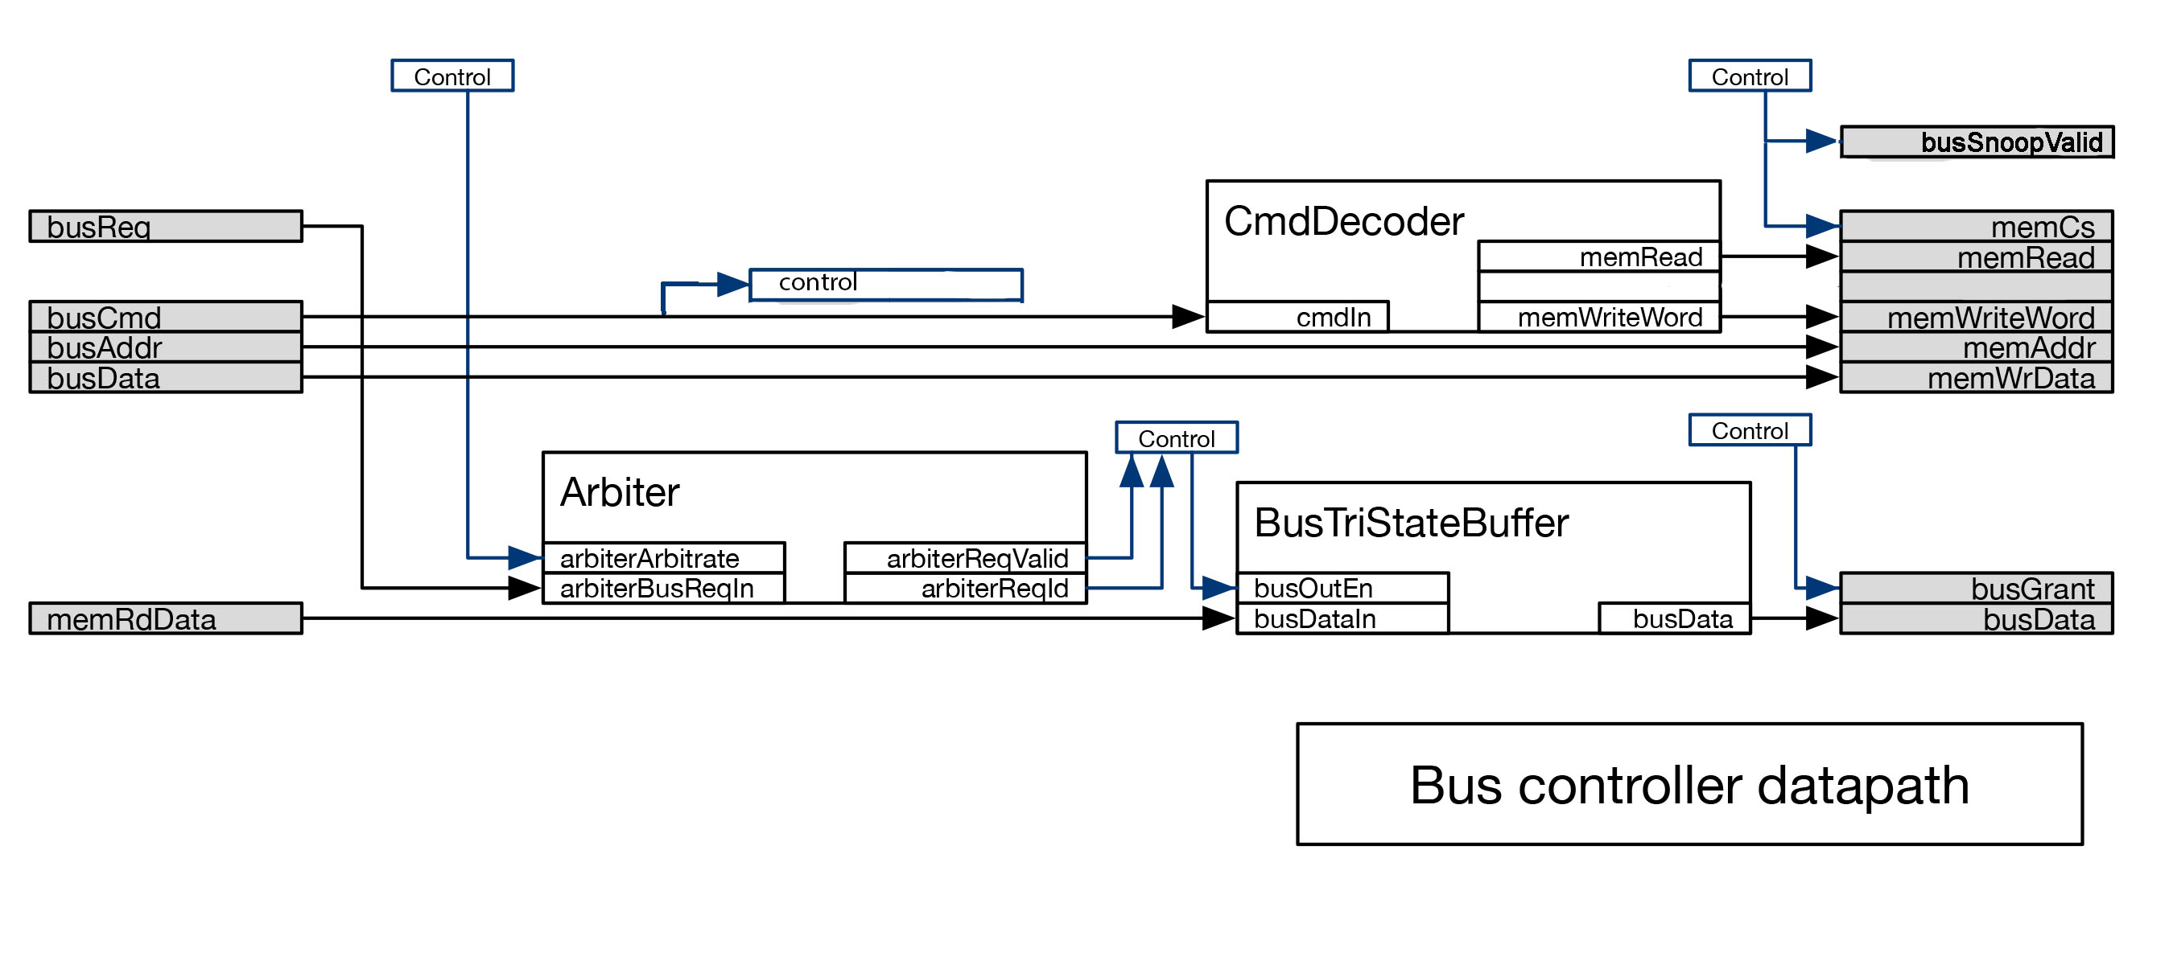

This is the new datapath for the Bus Controler. We have removed the memWrite out signal because now that the cache is write-through we will always write to memory word by word, so only keeping the memWriteWord signal is enough.
We also have added a new output signal named busSnoopValid used to allow the snooping machine to snoop. When this signal is zero the snoop machine stands by.
Also, we send the busCmd signal to the control to check if the signal is a WRITE and not a read, and in a case of a write we run the snoop machine.

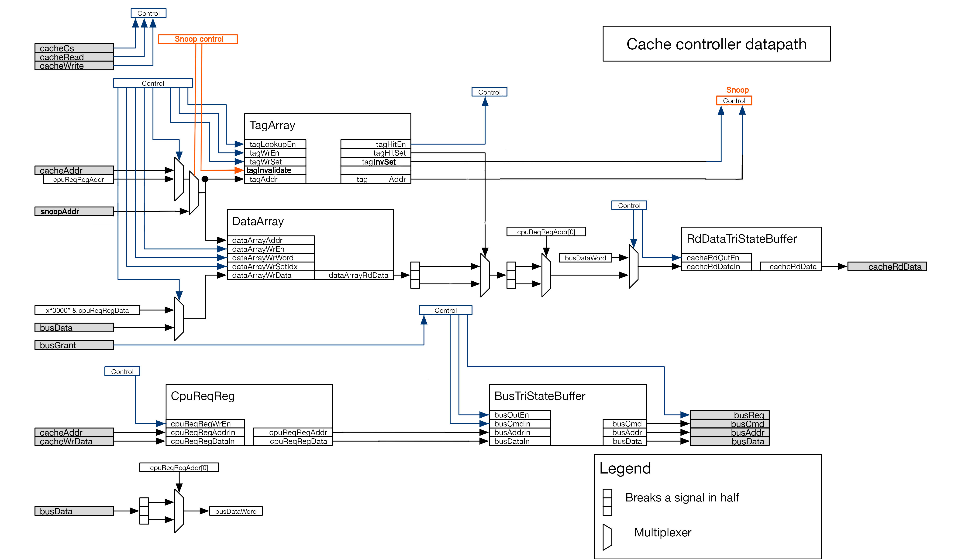
Cache Controller Datapath and new TagArray interface

For the cache controller datapath, more modifications had to be done.

First, we had to edit the TagArray interface. It now doesnt take a tagWrSetDirty input anymore, but instead a tagInvalidate signal used to tell the tagArray if we want to read some tag line (0) or invalidate it (1). In accordance to that modification, the tagInvalidate signal also commands a mux to choose between the usual cacheAddr and the new snoopAddr input to send to the tagAddr input.

The outputs of TagArray are also modified : we don’t need no tagVictimDirty, tagVictimSet and tagVictimAddr anymore as the VictimReg should be removed (it’s only useful for write-backs). We can add 2 outputs signals named toInvSet to give some feedback to the control about the line invalidation status, and a tagAddr signal that represents the line that has been invalidated.

As said earlier, we had to remove the victimReg, which is a write-back feature. We also removed all the victim signal occurrences in the datapath, often used to command muxes (which we also removed). Now the CpuReqReg outputs are directly mapped to the TriStateBuffer

Registers to keep / remove

The registers to remove are the VictimReg.
The registers to keep are the others.

New Snoop State Machine

!PrWr && BusRead / -

The new snoop machine stays in state idle when the BusSnoopValid signal is off. This signal is sent when we are authorized to snoop the bus. The corner case when we have a processor write or read signal coming and when we are yet not allowed to snoop the bus is treated in the left arrow (we stay in idle and ignore the PrWr and PrRd signal).

When we are authorized to snoop the bus and we see a busWrite signal, we can go to the busy state and send a tagInvalidate signal to the TagArray and send the busAddr to invalidate to the snoopAddr signal (that will also be used by the TagArray). Then we stay in the busy state and wait for the tagInvSet signal from the TagArray saying the invalidation has been done.

Another corner case we treated is when we recieve a PrWr and a BusRd at the same time, the PrWr is done first because it contains the youngest value. That means we only proceed to a BusRd when there is no PrWr.

Eventually, when the invalidation is over, we go back to the idle state.

